Student Workshop on Plant Physiology
“Understanding Plants: Plant Physiology, Molecular Biology and Biotechnology”

Atal Bihari Vajpayee Government College, Bangana, District Una, Himachal Pradesh
21st –22nd September, 2026
In association with the Indian Society for Plant Physiology
A two days Students' Workshop on “Understanding Plants: Linking Physiology, Molecular Biology and Biotechnology” was successfully organized by the Department of Life Sciences, A.B.V. Govt. Degree College, Bangana in collaboration with the Indian Society for Plant Physiology, New Delhi. The objective of the workshop was to create scientific curiosity among students about plant sciences and to provide hands-on understanding of the inter-linkage between Plant Physiology, Molecular Biology and Biotechnology for a sustainable future.
Patron and Organizing Team:
The workshop was held under the patronage of Prof. Sanjay Kumar, President, ISPP, New Delhi and Prof. Rekha Sharma, Principal, ABVGDC Bangana. The workshop was convened by Dr. Manoj K. Sharma, Joint Secretary, ISPP and co-convened by Prof. Nand Lal and Dr. Shruti, ABVGDC Bangana. The Organizing Secretary was Dr. Sanjay K. Sharma.
Resource Persons:
Eminent scientists and academicians were invited as resource persons:
- Dr. Manoj K. Sharma - School of Biotechnology, JNU, New Delhi
- Dr. Rohit Joshi - CSIR-IHBT, Palampur, H.P.
- Dr. Nitya Nandan Sharma - School of Biotechnology, JNU, New Delhi
- Dr. Amit Kumar - School of Biotechnology, JNU, New Delhi
- Dr. Garima - School of Biotechnology, JNU, New Delhi

About the Workshop:
A two-day student workshop on plant physiology was organised at Atal Bihari Vajpayee Government College, Bangana, District Una, on 21 and 22 September 2026. The workshop focused on connecting plant physiology with molecular biology and biotechnology and providing students with scientific and practical understanding of important biological processes in plants.
The programme was organised with the support of the Indian Society for Plant Physiology. It was conducted in the college conference hall and included participation by students from the college as well as students from other states.
Institution | Atal Bihari Vajpayee Government College, Bangana, District Una
Programme | Two-day student workshop on plant physiology
Dates | 21–22 September 2026
Venue | College Conference Hall
Theme | Plant physiology, molecular biology and biotechnology
Reported participation | 35 students, including participants from other states
Supporting organisation | Indian Society for Plant Physiology

Objectives:
- To introduce students to the basic concepts of plant physiology.
- To explain the relationship between plant physiology, molecular biology and biotechnology.
- To develop scientific and practical understanding of biological processes occurring in plants.
- To familiarise students with molecular foundations and modern applications of biotechnology.
- To provide students with meaningful academic and research-oriented exposure.

Student Participation:
A total of 35 students participated in the two-day workshop, including students from Rayat Bahra University, GC Ludhiana and GC Una. All participants were from medical stream. The college administration also indicated that similar lectures, workshops, seminars and other educational programmes would be organised in future to provide students with quality academic and research opportunities.

Academic Highlights:
Area | Highlight
Plant Physiology | Students were introduced to physiological processes and their importance in understanding plant function.
Molecular Biology | The workshop connected plant-level processes with molecular mechanisms and the biological basis of plant functions.
Biotechnology | The programme highlighted the relevance of modern biotechnology and its applications in plant science.
Interactive Learning | Photographs show students actively participating in presentations, discussions and question–answer sessions.
Research Orientation | The programme was designed to provide exposure to academic and research opportunities beyond routine classroom learning.

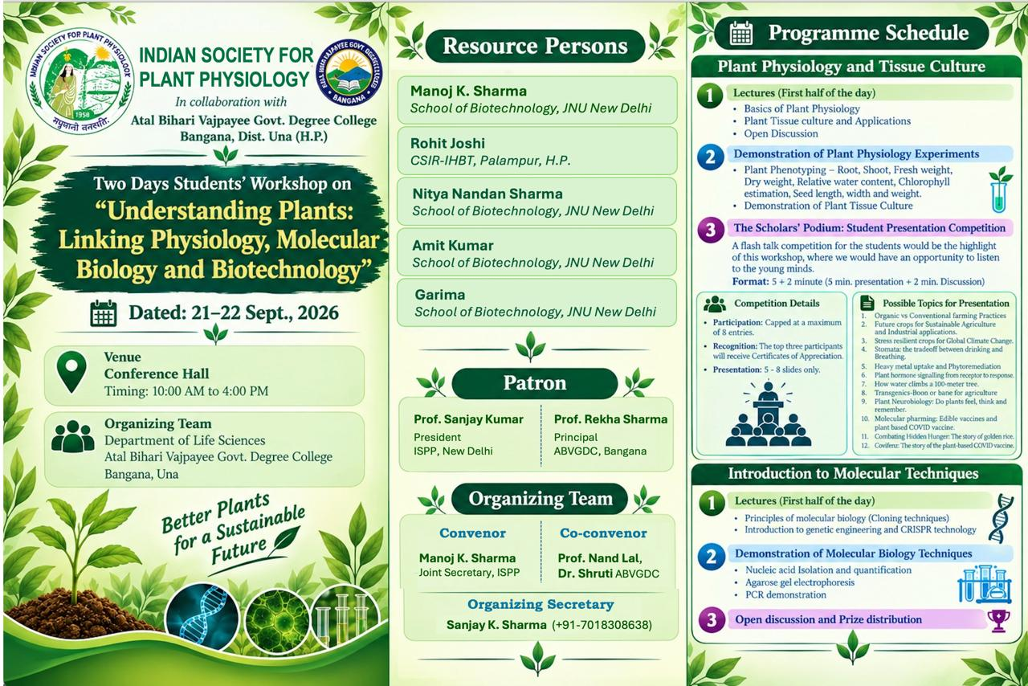
Schedule of two day workshop on “Understanding Plants: Linking Physiology, Molecular Biology and Biotechnology”

Workshop Proceedings — 21st September 2026

Day 1: Plant Physiology and Tissue Culture
Lectures: The first half included lectures on Basics of Plant Physiology, Plant Tissue Culture and Applications followed by an open discussion.
Demonstration: In the second session, demonstration of Plant Physiology experiments was conducted including Plant Phenotyping – Root, Shoot, Fresh weight, Dry weight, Relative water content, Chlorophyll estimation, Seed length, width and weight and demonstration of Plant Tissue Culture techniques.
There were interactive academic sessions in the conference hall. Students gave their presentations, participated in discussions and engaged with the resource persons.
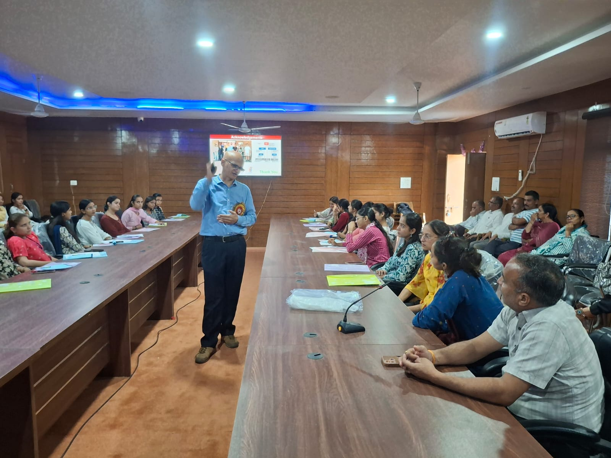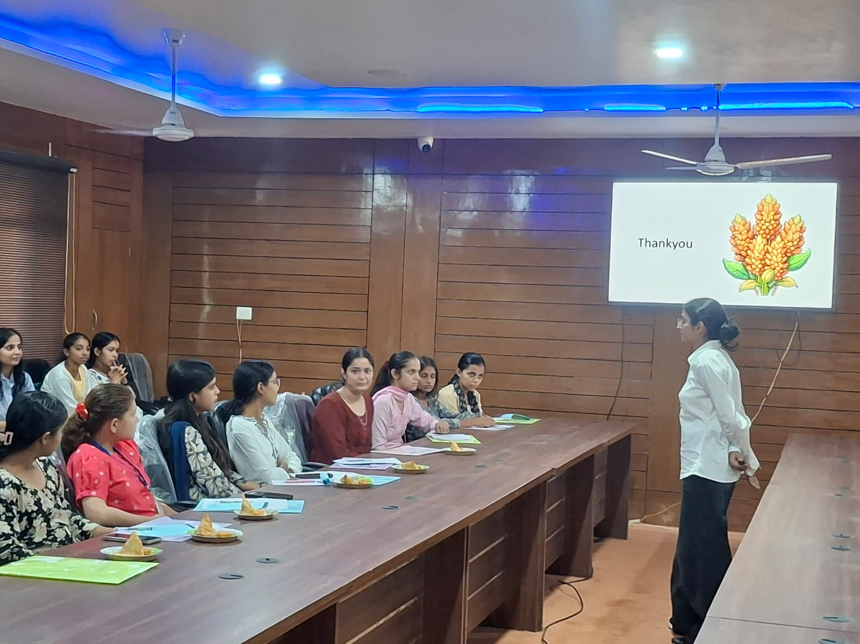
Presentations by Prof. Manoj K. Sharma, JNU, New Delhi and Ms. Garima, Research Scholar, JNU, New Delhi

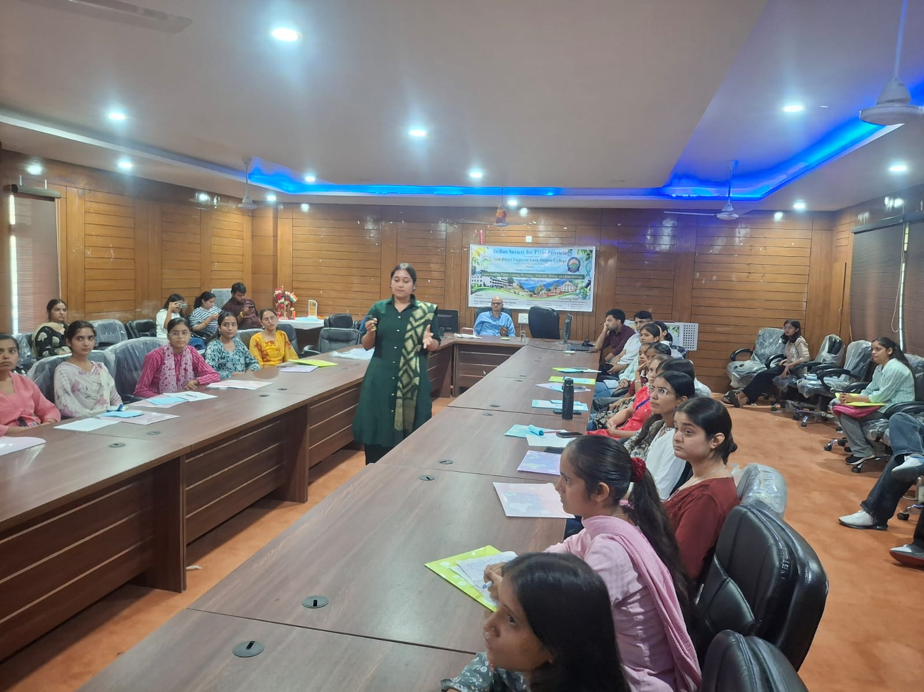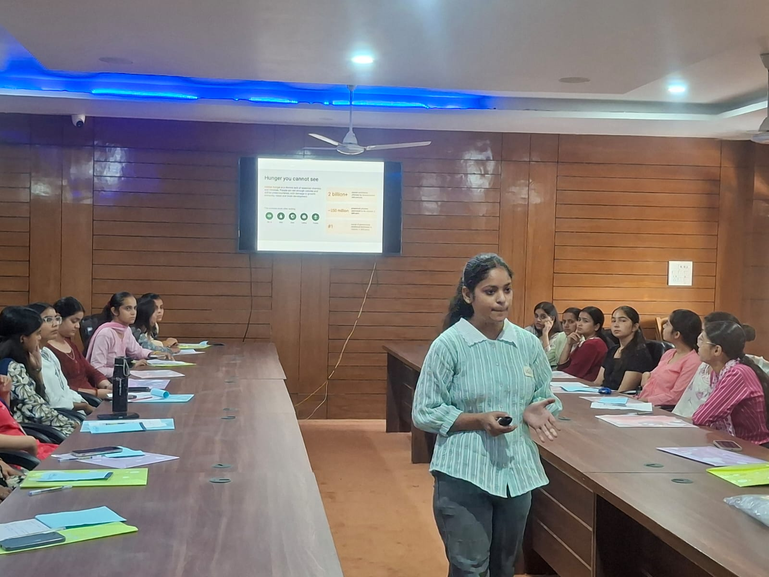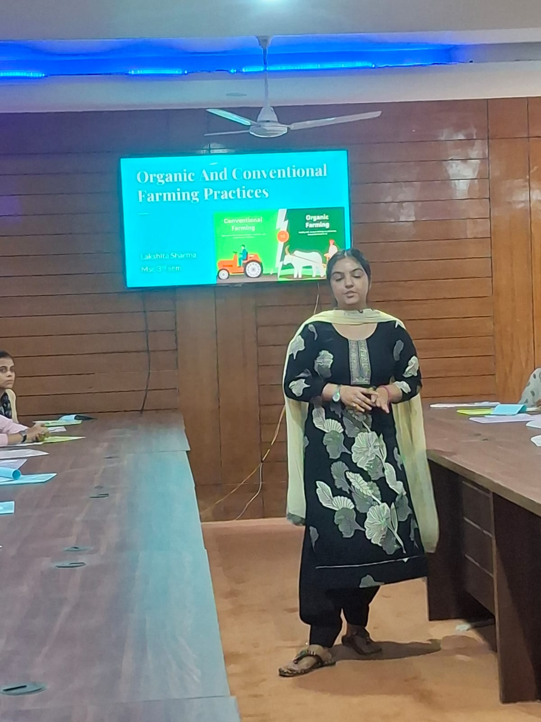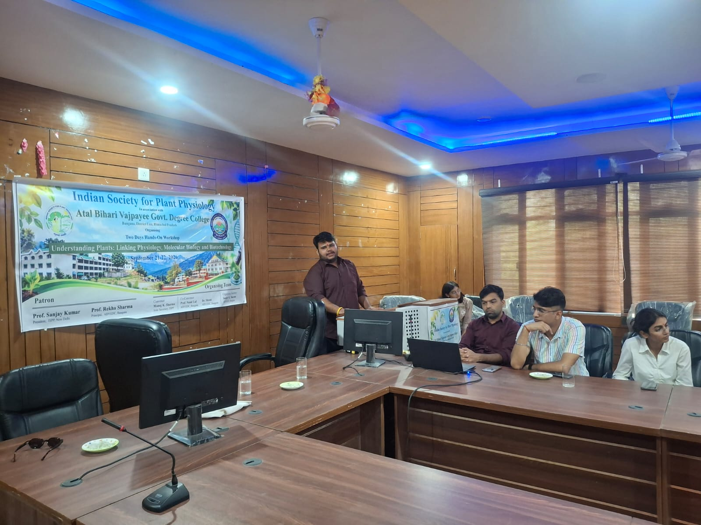
Glimpses of student presentations/discussions during the workshop

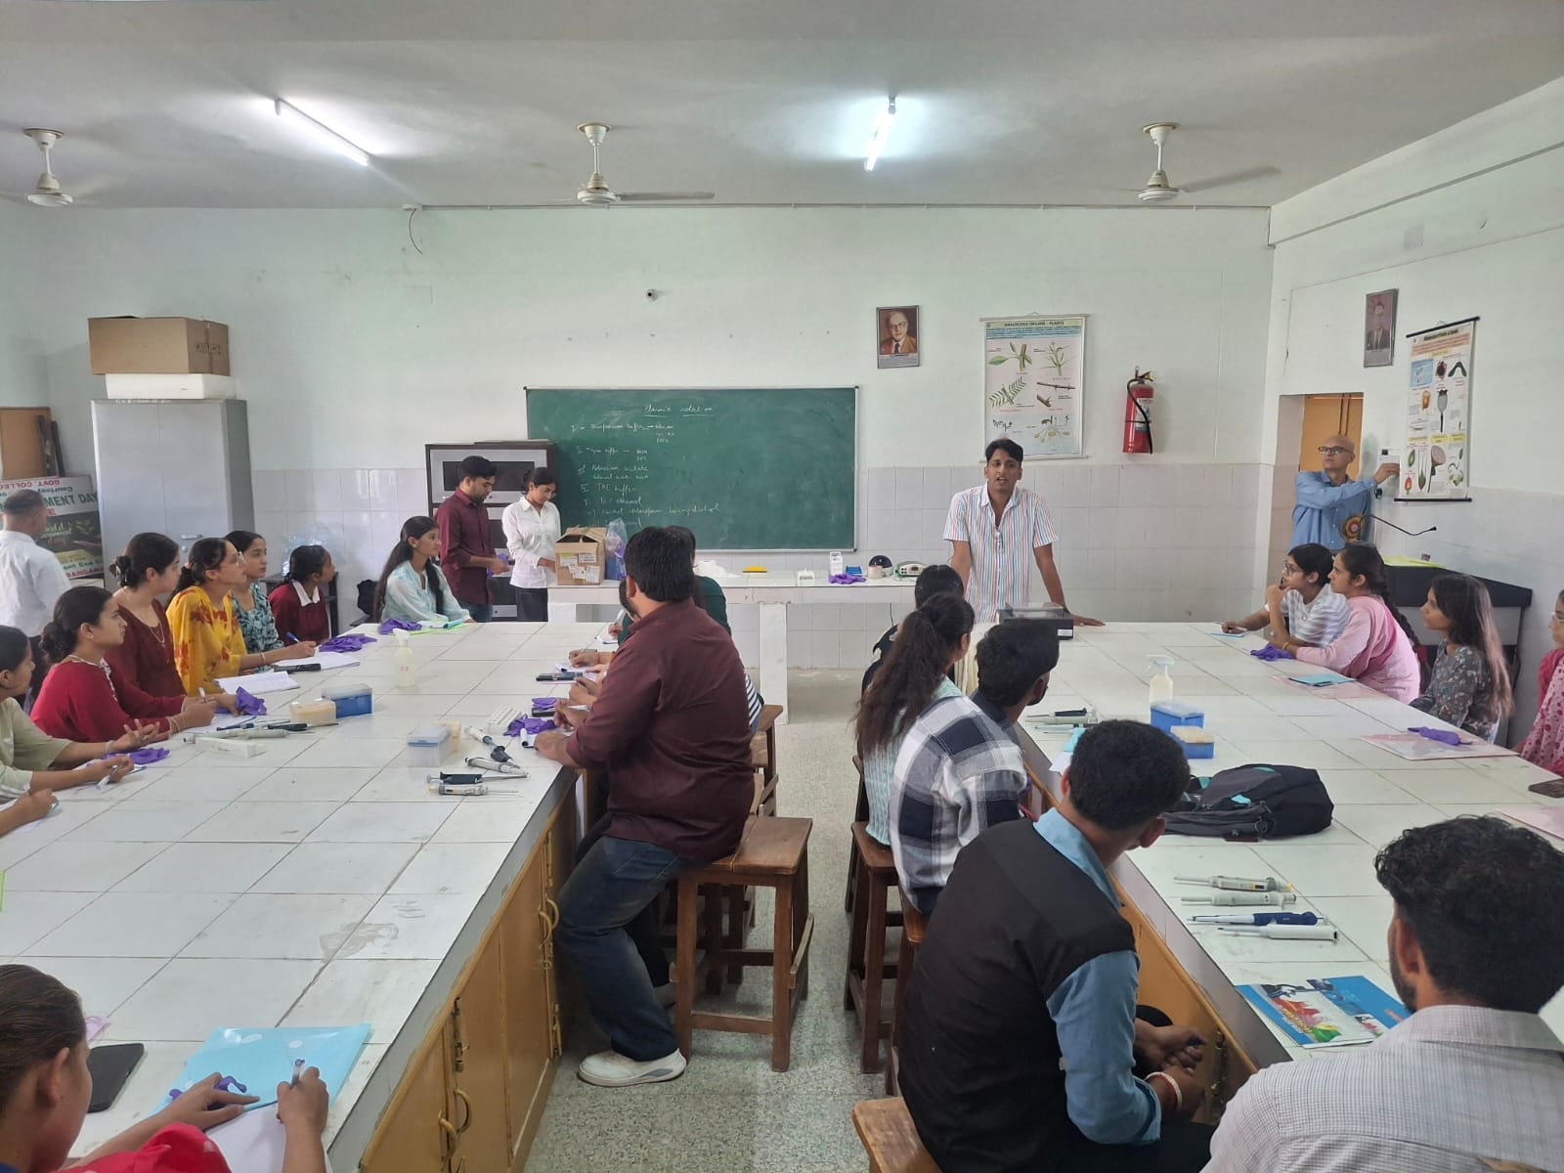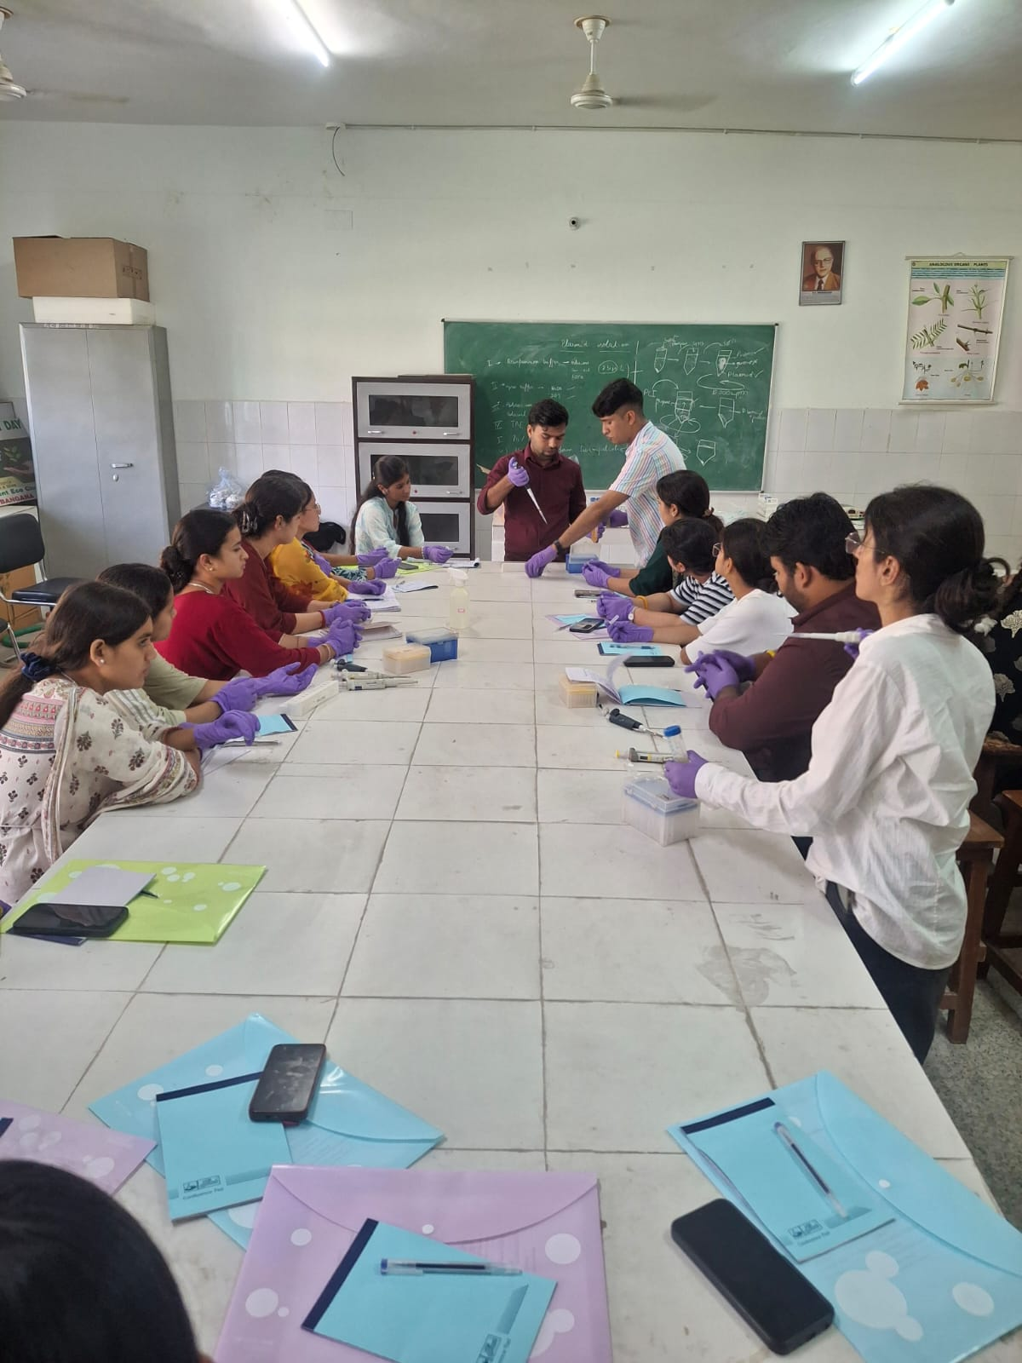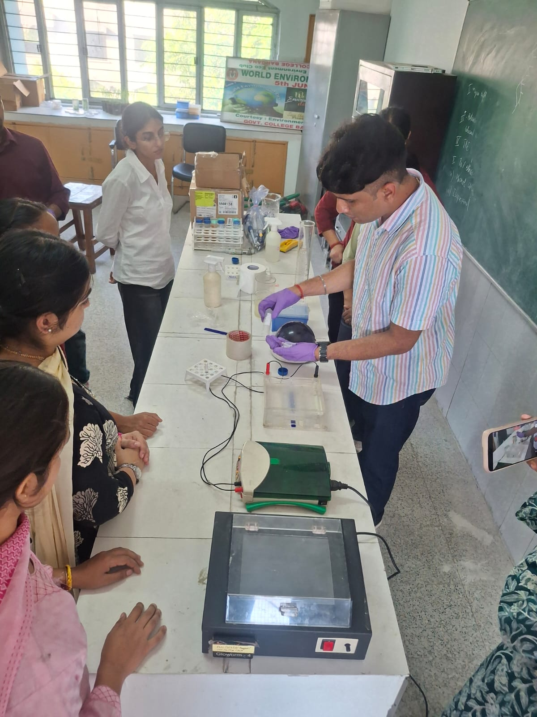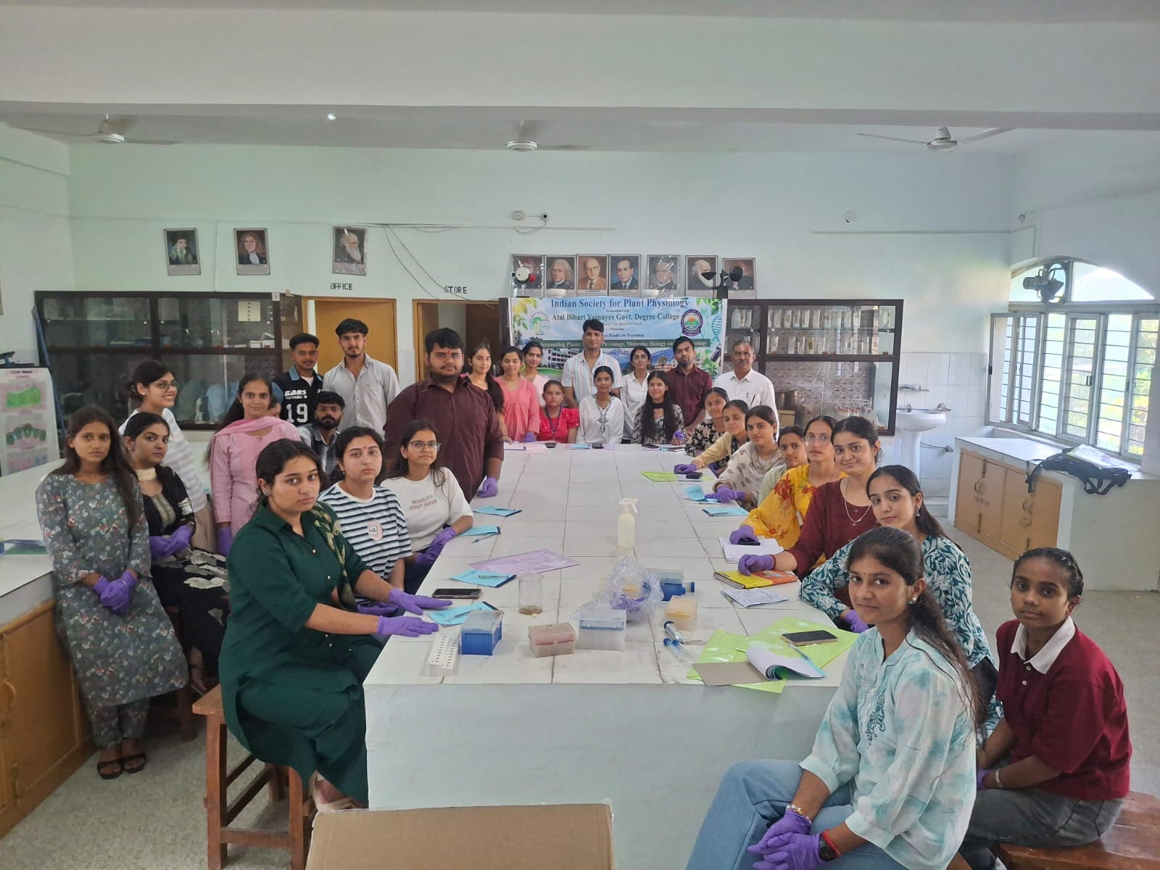

Glimpses of demonstrations and Hands on training of different techniques of Molecular biology techniques by the team of JNU, New Delhi

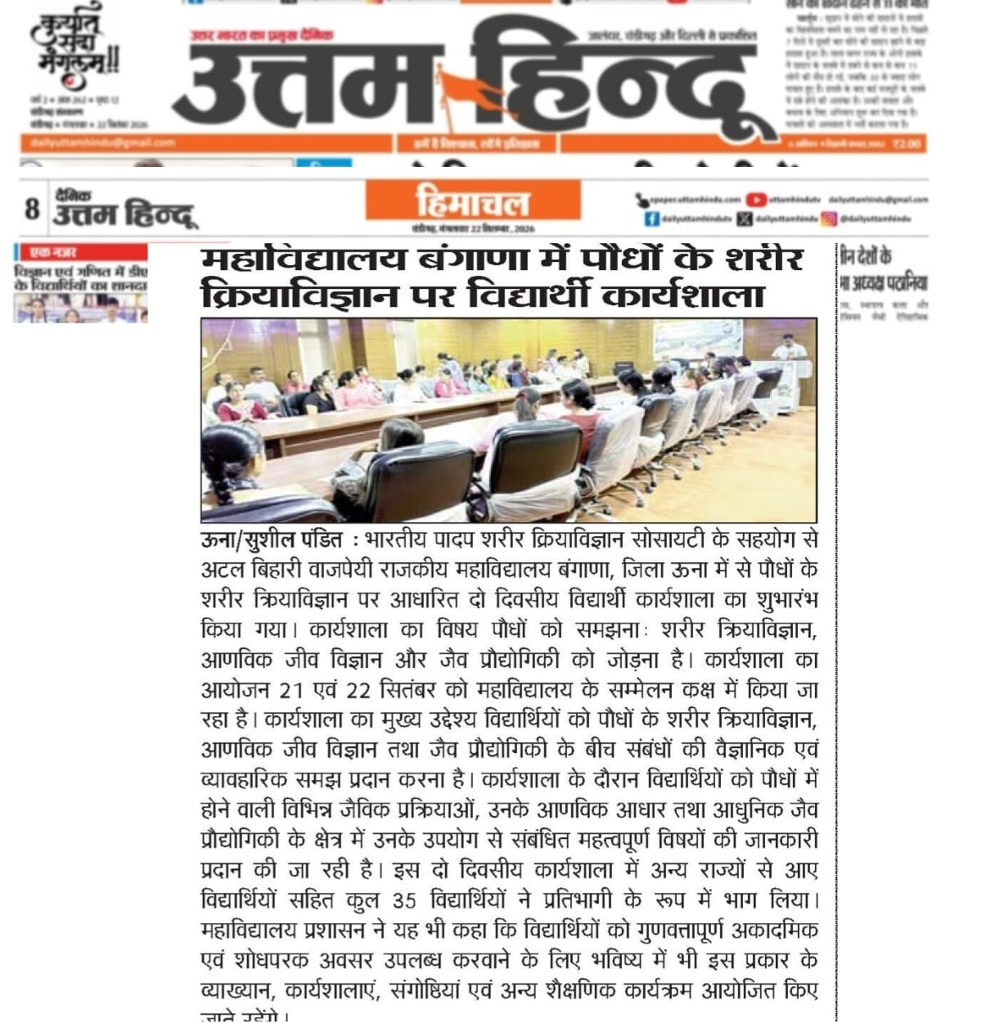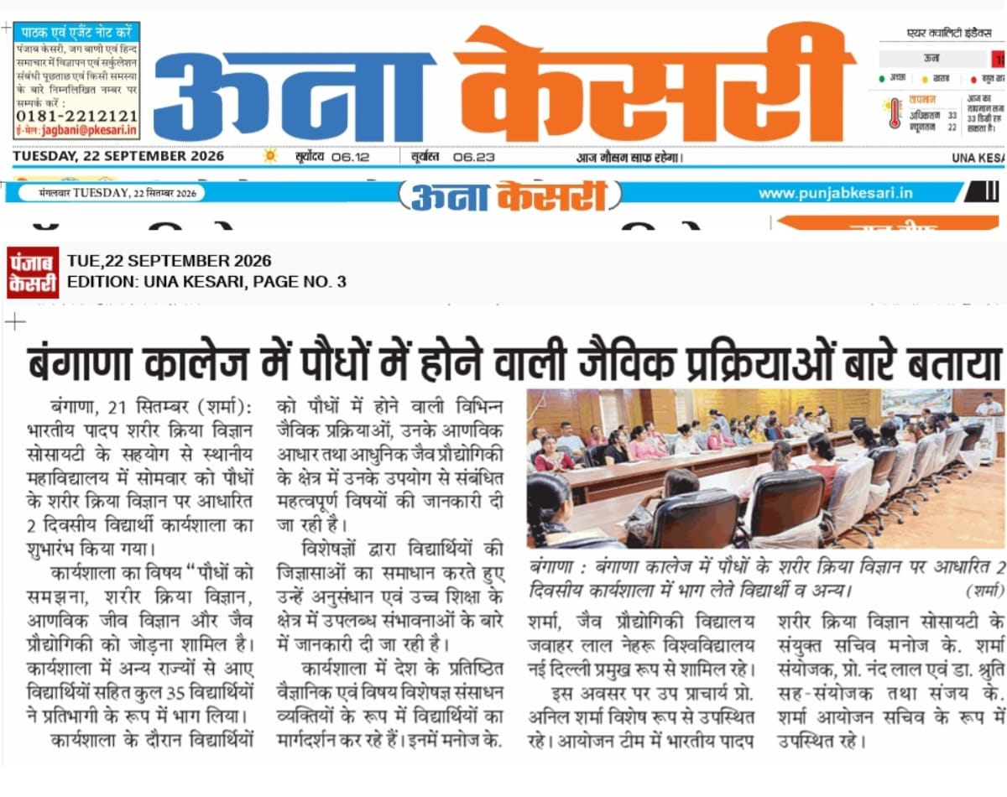

Articles published in various newspapers

Workshop Proceedings — 22nd September 2026

Day 2: Plant Physiology and Biotechnology
Lectures: The first half included lectures on Emerging trends in plant biotechnology for climate resilience and food security, transgenic plants and responses in plants under stress followed by an open discussion.
Demonstration: Hands-on demonstration of Nucleic acid isolation and quantification, Agarose gel electrophoresis and PCR was conducted.
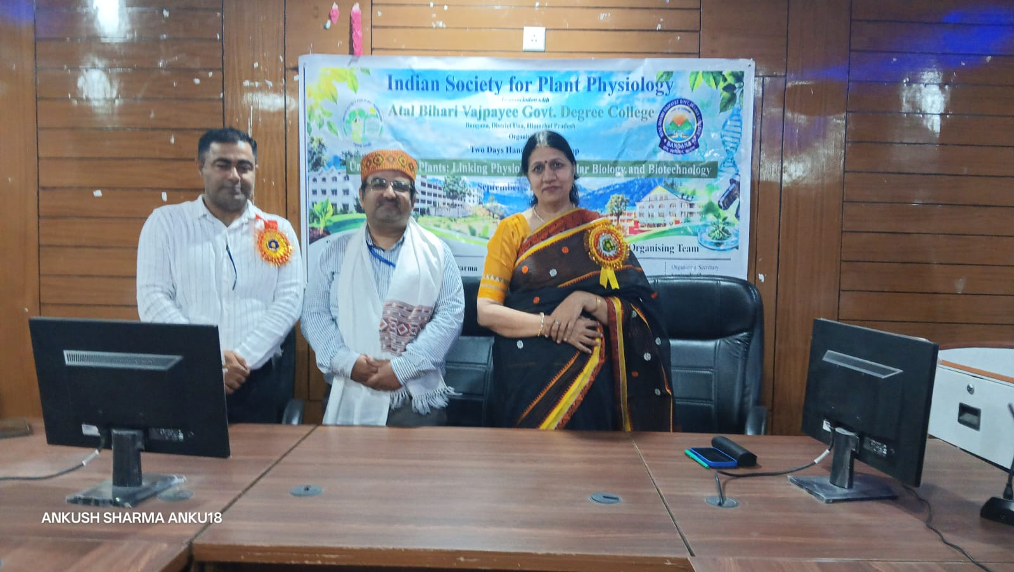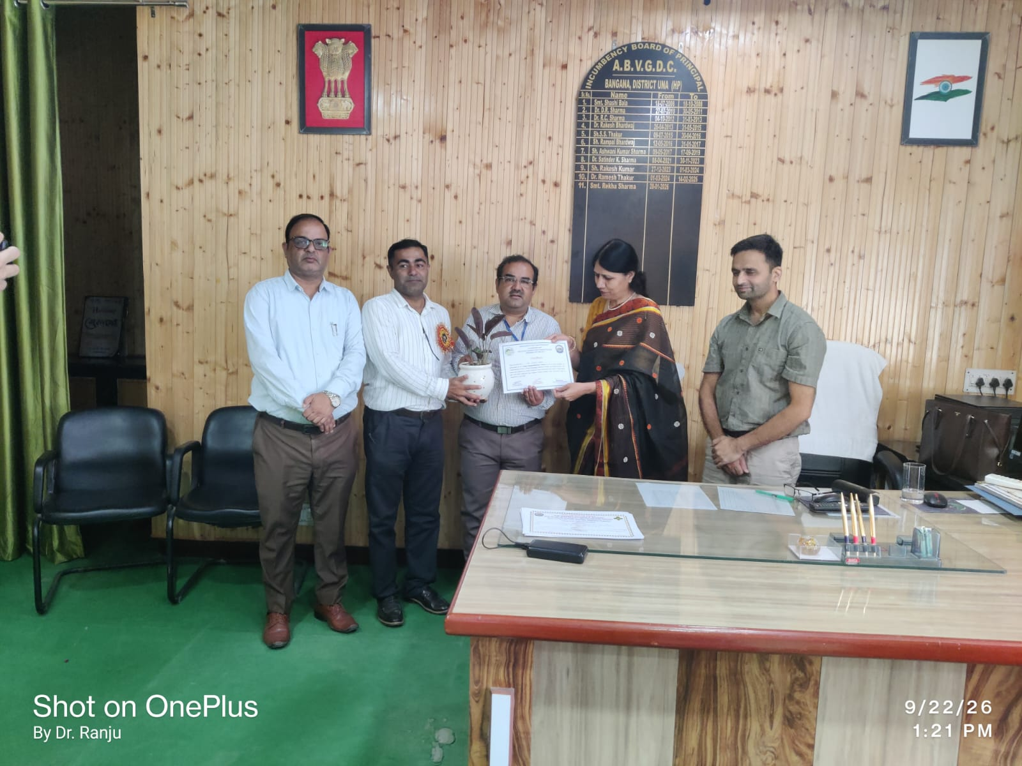
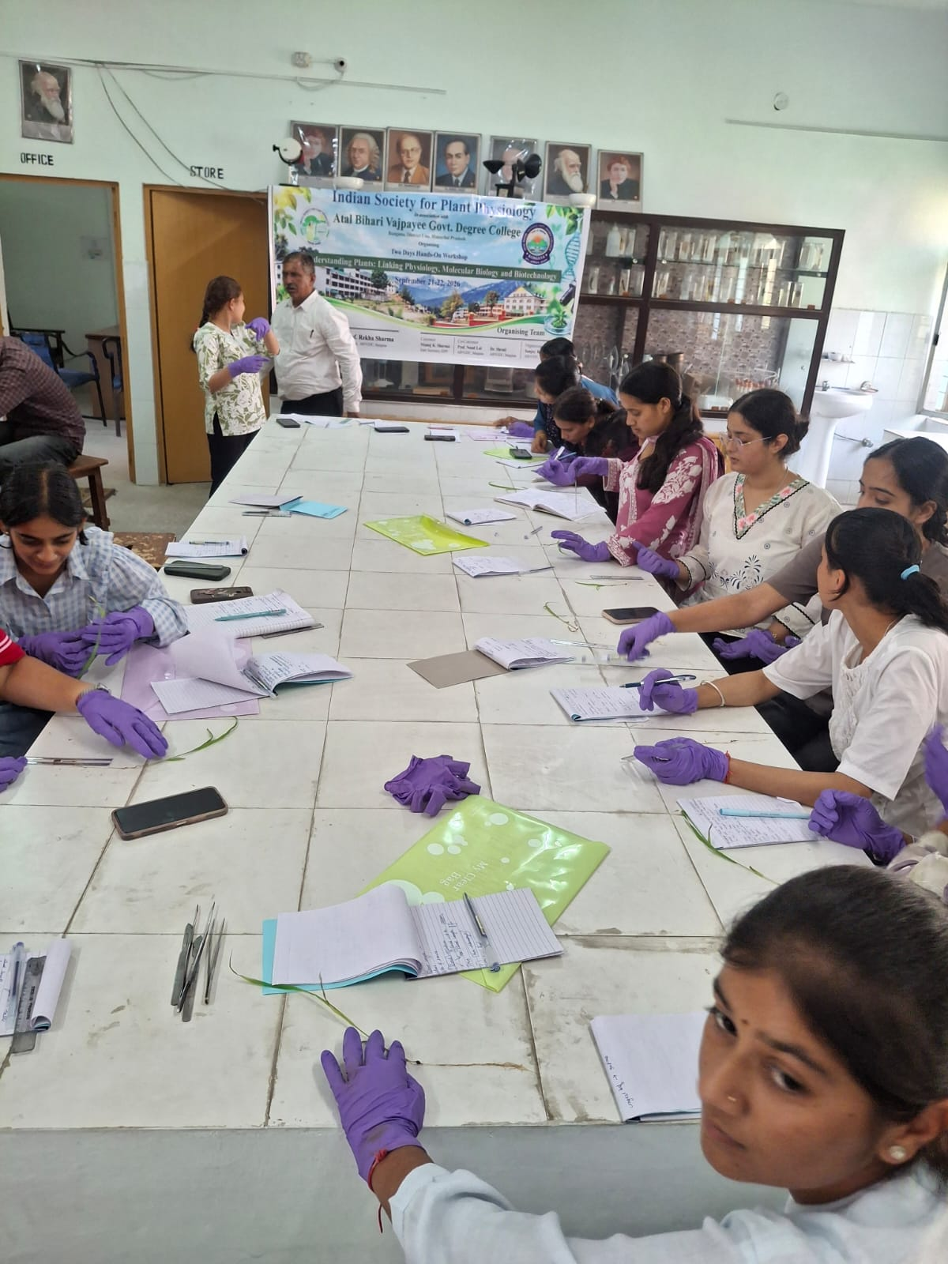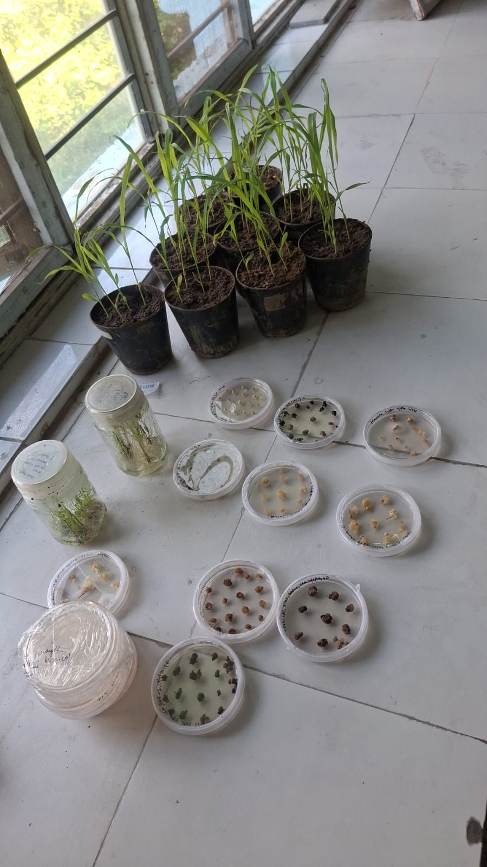
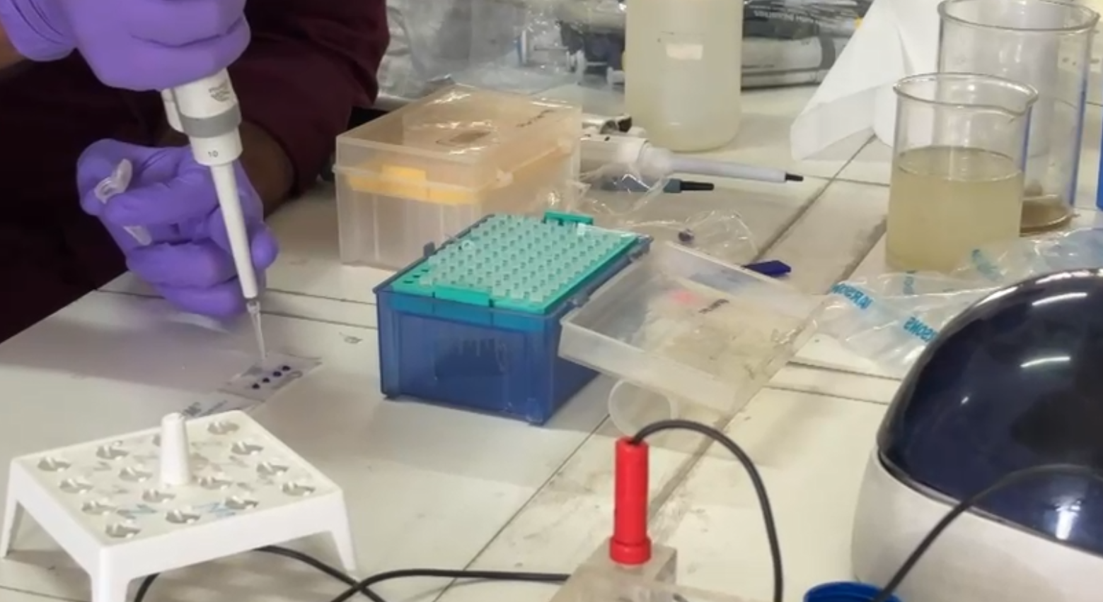

Glimpses of demonstrations and Hands on training of different techniques of Biotechnology by the team of CSIR-IHBT, Palampur

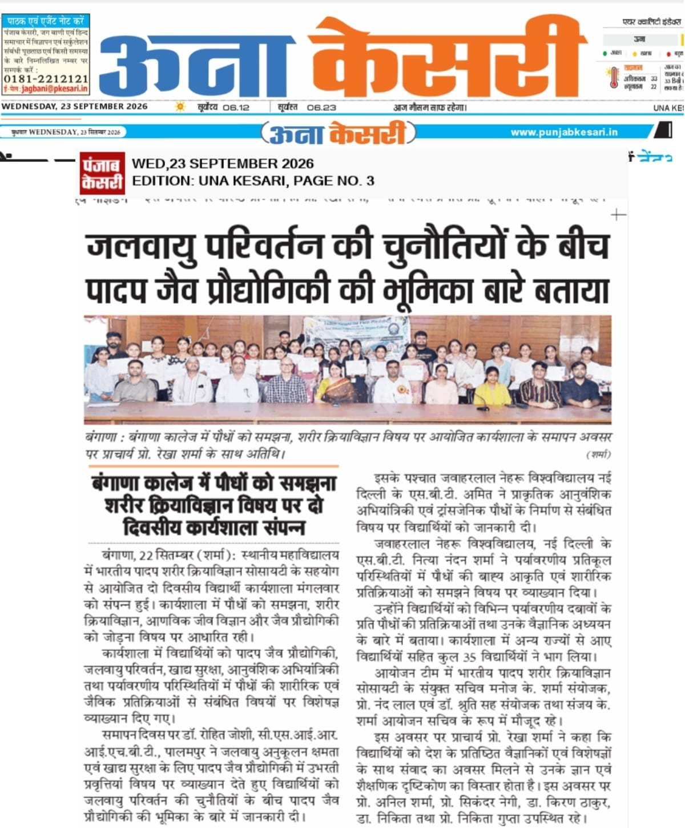

Article published in newspaper
Conclusion:
The workshop effectively achieved its objectives of introducing students to basic concepts of plant physiology, explaining the inter-relationship between physiology, molecular biology and biotechnology, and providing hands-on exposure to modern techniques like plant phenotyping, tissue culture, nucleic acid isolation, agarose gel electrophoresis and PCR.
The interactive lectures by resource persons from JNU New Delhi and CSIR-IHBT Palampur – Dr. Manoj K. Sharma, Dr. Rohit Joshi, Dr. Nitya Nandan Sharma, Dr. Amit Kumar and Ms. Garima – along with student presentations under “The Scholars’ Podium”, open discussions, and laboratory demonstrations made the learning research-oriented and beyond routine classroom teaching.
The event was covered in the local press which highlighted the role of plant biotechnology in addressing challenges of climate change and food security.
Overall, the workshop generated scientific curiosity, enhanced practical understanding, and provided meaningful academic and research exposure to the students.
The college administration assured that similar lectures, workshops and seminars will be organized in future to provide quality academic opportunities.
The Principal, Prof. Rekha Sharma congratulated the Department of Life Sciences and ISPP for organizing the workshop on a relevant theme of “Better Plants for a Sustainable Future.”
The programme concluded with certificate distribution and a vote of thanks by the organizing team.

(Prof. Sanjay Sharma)
Organizing Secretary
Principal,
ABVGC Bangana
Distt. Una, H.P.

